CSC4161
Advance Programming in Web Technology
Project Proposal Guide
and Sample Project Report
Backend REST API project: requirements, proposal format, report format and a worked example.
Inside this document
Part A | Project guide: what to build, what the proposal contains, how the report is written
Part B | Sample report for a made-up project called LibraSync, covering every report section

Issued October 2026. Dates, group size and marking details are set by your course instructor; where this guide gives a suggestion, it says so.

Contents

Part A: Project guide
1. Purpose and scope of the project
2. Suggested timeline
3. What the proposal must contain
4. Minimum requirements
5. Bonus requirements
6. Choosing a topic
7. Recommended stack and project structure
8. Writing the project report
9. Proposal template
10. Submission checklist

Part B: Sample report (LibraSync)
Cover page with group, contribution and AI usage table
1. Background study
2. Requirement analysis
3. Use case diagram and ER diagram
4. Database normalization
5. List of APIs
6. Screenshots of functionality
7. Implementation highlights
8. Conclusion and references

How to use Part B
Part B shows the depth, layout and kind of evidence expected in a finished report. The project, names, IDs and numbers in it are invented. Do not copy its content: your report must describe your own system, with your own diagrams, tables and screenshots.

Part A: Project guide

1. Purpose and scope of the project
In CSC4161 each group builds a backend web service that solves a real problem. The service exposes a REST API, keeps its data in a relational database, protects its routes with JWT, and handles bad input and failures in a controlled way. You are assessed on how fully the finished system meets the requirements in this guide and on how clearly you document it.
The work has four deliverables: a short proposal, the working source code in a Git repository, a project report in the format of Section 8, and a live demo.
Assumed stack
This guide assumes NestJS with TypeScript, TypeORM and a relational database (PostgreSQL or MySQL), because the requirement list is written in NestJS terms: DTOs, decorators, interceptors, middleware. If your instructor accepts another stack, the same requirements apply with the equivalent tools.

Item | Detail
Course | CSC4161 Advance Programming in Web Technology
Deliverables | Proposal, source repository, project report (docx or PDF), live demo
Group size | As announced by your instructor. The sample report is written for four members.
Frontend | Not required. Demonstrate the API through Swagger UI or Postman.
Repository | Git repository with a README, .env.example, migration files, and commits from every member

2. Suggested timeline
Use the dates your instructor announces. This table is a reasonable default for a 13-week term.
Phase | Suggested timing | What you hand in
Form group and choose a topic | Weeks 1–2 | Group list and topic idea
Proposal | Week 3 | Two to three page proposal (Section 3)
Proposal feedback | Week 4 | Revised proposal, if asked
Build: auth, entities, CRUD | Weeks 5–8 | Progress demo
Build: transactions and bonus features | Weeks 9–11 | Progress demo
Report and final demo | Weeks 12–13 | Report, repository link, live demo

3. What the proposal must contain
The proposal is short, two to three pages. Its job is to show that your idea is large enough to meet the minimum requirements and that you have thought about how to build it.
Part | What to write
Cover details | Project title, group number, and each member's ID, name and section.
Problem statement | The problem, who has it, and how it is handled today. One paragraph.
Objectives | Three to five goals you can check at the end, for example: a librarian can issue a book and the stock count changes in the same transaction.
Scope | What the API will do, and what it will not do.
Entities | A table of entities with their main fields and relationships. Aim for at least four entities, with at least one one-to-many and one many-to-many relationship.
Roles and access | The user roles (for example Admin, Staff, Member) and what each may do.
Planned endpoints | A summary list grouped by module.
Transaction scenario | One operation that changes two or more tables and must succeed or fail as a unit.
Bonus features | Which bonus features you will build and where each one will be used in the system.
Tools | Framework, database, libraries, version control, API testing tool.
Work plan | Who builds which module, and the week each part is due.

4. Minimum requirements
Every project must meet all five. A project that misses one is incomplete, whatever bonus features it has.
Requirement | What it means in practice | Evidence to show
Multiple entities with CRUD endpoints | At least four related entities. Each core entity has create, read (list and by id), update and delete endpoints. Use the right HTTP verb and status code (201 on create, 404 when missing). Lists should support pagination. | Swagger UI or Postman run through every endpoint
Database integration and data transaction | A relational database accessed through an ORM, with entity relations and foreign keys. At least one operation that touches two or more tables runs inside a transaction and rolls back when a step fails. | Tables in a DB client; a deliberate failure that leaves the data unchanged
Authentication and authorization with JWT | Register and login. Passwords stored as bcrypt hashes. Protected routes check the token. At least two roles with different permissions, enforced by guards. | Login response; 401 without a token; 403 for the wrong role
Input validation with DTOs | Separate DTO classes for create and update, with class-validator rules. A global ValidationPipe strips unknown fields. Bad input returns 400 with a message that says which field failed. | A request with invalid body and the 400 response
HTTP exception handling | Use the built-in exceptions (NotFoundException, ConflictException, ForbiddenException and so on). Return one consistent error shape. Never leak stack traces. Turn database errors such as a duplicate unique key into a 409. | 404, 409 and 403 responses with a readable body

5. Bonus requirements
Bonus features are optional. Choose the ones that fit your system and make each one do real work. A feature added only to tick the list, such as an interceptor that does nothing useful, is easy to spot at the demo.
Feature | What to build | Example
Middleware | A class or function that runs before the route handler and touches every request. | Request logger that prints method, path, status and duration; request-id header
Custom decorators | Your own decorators for metadata or parameters. | @Roles('admin'), @CurrentUser(), @Public()
Mailer | Send real emails from the application using a mail module and templates. | Welcome email on registration; order or loan receipt. Use an SMTP sandbox such as Mailtrap while testing.
Swagger UI | Interactive API documentation generated from the code. | Docs at /api/docs, with @ApiTags, @ApiProperty and bearer auth enabled
Interceptors | Code that wraps handler execution to transform the result or measure it. | Response timing, response wrapper, cache
Audit log | A table that records who changed what and when. | User, action, entity, id, old and new values, IP, time, written for every create, update and delete
Env | Configuration kept outside the code. | .env read through ConfigModule, validated at start-up, with a committed .env.example and no secrets in Git
Migrations | Versioned schema changes instead of automatic synchronization. | Generated migration files; synchronize switched off; a fresh database built by running them
Response manipulation | Shape what the client receives. | A { success, message, data, meta } envelope; password hash excluded; pagination metadata
Database transaction (advanced) | Go beyond the single transaction in the minimum requirements. | Manual QueryRunner commit and rollback, row locking to stop double booking, several transactional workflows

Check this with your instructor
The requirement list names a data transaction as a minimum and a database transaction as a bonus. This guide reads that as: minimum is one working multi-step operation inside a transaction; bonus is more advanced use such as explicit QueryRunner control and locking. Confirm that reading before you plan your work.

6. Choosing a topic
A good topic has several roles, at least four connected entities, and one action that must change more than one table at once. These are all workable:
Topic | Core entities | Operation that needs a transaction
Library management | users, books, authors, categories, borrow records | Issue book: create loan and reduce available copies
Online food ordering | users, restaurants, menu items, orders, order items | Place order: save order and items, update stock
Hospital appointments | users, doctors, departments, slots, appointments | Book slot: create appointment and mark slot taken
Event ticketing | users, events, venues, tickets, orders | Buy tickets: reduce seats, create ticket rows
Course platform | users, courses, lessons, enrollments, payments | Enroll: create enrollment and payment record
Hotel booking | users, rooms, room types, bookings, payments | Book room: check availability, create booking, update room
Job portal | users, companies, jobs, applications, skills | Apply: create application and update vacancy count

Topics to avoid: a to-do list or blog with one real table, an exact copy of a tutorial project, a system with only one role, and a design whose entities have no relationships between them.

7. Recommended stack and project structure
Concern | Suggested tool
Framework | NestJS with TypeScript
Database | PostgreSQL (MySQL is acceptable)
ORM and migrations | TypeORM
Authentication | @nestjs/jwt, passport-jwt, bcrypt
Validation | class-validator, class-transformer
API documentation | @nestjs/swagger
Configuration | @nestjs/config, optionally with Joi for validation
Email | @nestjs-modules/mailer with nodemailer; Mailtrap or similar for testing
Testing the API | Swagger UI and Postman; Jest if you have time
Diagrams | draw.io, dbdiagram.io, Lucidchart or PlantUML
Version control | Git and GitHub

A folder layout that keeps shared code apart from feature modules:
src/
main.ts bootstrap, ValidationPipe, Swagger
app.module.ts
config/ env loading and validation
common/
decorators/ @Roles, @CurrentUser, @Public
filters/ global exception filter
guards/ JwtAuthGuard, RolesGuard
interceptors/ response wrapper, audit, timing
middleware/ request logger
database/
data-source.ts TypeORM CLI data source
migrations/
auth/ controller, service, strategy, DTOs
users/
<your-module>/ entity, controller, service, dto/
mail/
audit/

8. Writing the project report
The report has seven parts. The cover page is unnumbered in the sample; numbered chapters start at the background study.
Part | Must include | Common mistakes
1. Cover page | Title, course, group, semester, submitted-to. A table with, for every student: ID, name, section, contribution, and AI usage percentage. | Writing 'worked on everything' as the contribution. Leaving the AI percentage blank.
2. Background study | The problem domain, two or three existing systems compared with yours, and the technologies you chose and why. | Pasting product marketing text. No comparison.
3. Requirement analysis | Numbered functional requirements with priority. Non-functional requirements with a category, a measurable target and a way to check it. | Non-functional items such as 'the system should be fast' with no number.
4. Use case and ER diagram | Actors, a use case diagram, descriptions of the main use cases, an ER diagram showing keys and cardinality, and a table that explains each relationship. | ER diagram that does not match the real database. Missing cardinality.
5. Database normalization | A realistic unnormalized record taken through 1NF, 2NF and 3NF, stating the dependency removed at each step. | Showing only the final tables.
6. List of APIs | Every endpoint with method, path, purpose and required role. Sample request and response bodies. Status codes used. | Listing endpoints that are not in the code or not in Swagger.
7. Screenshots | One per major function, including failures: 401, 403, 400, 409 and a transaction rollback. Each captioned. | Showing only happy paths. Images with the URL and status cropped out.

AI usage percentage
For each member, state the share of that member's own work (code, diagrams, report text) that was drafted or generated with an AI tool, as a percentage. Under the table, list the tools and what they were used for. Follow your instructor's AI policy; if it caps AI use, your figure must stay inside the cap. Every member must be able to explain any part of the code they submit.

9. Proposal template
Copy this table into a new document and fill in the right-hand column.
Field | Your entry
Project title | A short name and one-line description
Group and members | Group number; for each member: ID, name, section
Problem statement | One paragraph
Objectives | Three to five checkable goals
Scope and exclusions | What is in, what is out
Entities and relationships | Table: entity, main fields, relations (one-to-many, many-to-many)
Roles and access rules | Table: role, allowed actions
Planned endpoints | Grouped by module
Transaction scenario | The operation, the tables it touches, what happens on failure
Bonus features chosen | Feature and where it will be used
Tools and libraries | Framework, database, libraries
Work plan | Member, module, due week

10. Submission checklist
Area | Check before you submit
Code | ☐ All five minimum requirements work  ☐ At least four entities with relations  ☐ README explains how to install, configure and run  ☐ .env.example is present and no real secrets are committed  ☐ Migrations build the schema on an empty database
Report | ☐ Cover table is complete for every member, including AI usage  ☐ All seven parts are present  ☐ Diagrams are readable and match the database  ☐ API table matches Swagger  ☐ Every screenshot has a caption and shows the URL and status
Demo | ☐ Test data is loaded  ☐ Success and failure cases are ready to run  ☐ Every member can explain every module

University name · Department of Computer Science
CSC4161 · Advance Programming in Web Technology
Project Report
LibraSync
A Library Management REST API
Group information
Group number | 07
Semester | Fall 2026
Submitted to | Faculty name, Designation
Submission date | Date of submission

Group members, contribution and AI usage
SL | Student ID | Name | Section | Contribution | AI usage
1 | 22-48123-1 | Tanvir Ahmed | A | Auth and users modules, JWT strategy and guards, @Roles and @CurrentUser decorators, request logger middleware | 15%
2 | 22-47990-1 | Nusrat Jahan | A | Books, categories and authors modules, DTO validation, Swagger setup, response wrapper | 20%
3 | 22-48356-2 | Sabbir Hossain | B | Borrow and return transactions, fines, mailer module and templates | 10%
4 | 22-48201-1 | Maliha Rahman | A | Database design, migrations, audit log and interceptors, diagrams and report editing | 25%

AI usage is each member's own estimate of the share of their work (code, diagrams, report text) drafted or generated with an AI tool. Tools used: ChatGPT and GitHub Copilot, for boilerplate code, explaining error messages and rewording report text. All generated code was read, tested and edited by the member who submitted it.

1. Background study

1.1 Project overview and objectives
LibraSync is a REST API for running the catalogue, membership and lending of a small university library. Librarians keep books, authors and categories up to date and issue and receive books. Members search the catalogue and see their own loans and fines. An administrator manages staff accounts and can read an audit trail of every change.
The project has four objectives:
- Provide CRUD endpoints for users, categories, authors, books, borrow records and fines.
- Keep stock counts correct by issuing and returning books inside database transactions.
- Restrict every operation by role using JWT authentication and guards.
- Record every state change in an audit log and notify members by email.
The scope is the backend only. There is no web or mobile client; the API is exercised through Swagger UI and Postman. Online payment, book reservations and barcode scanning are outside the scope.

1.2 Problem domain
Many small libraries still track loans in a paper register or a spreadsheet. Three problems come up again and again. The stock count drifts from what is on the shelf because two people update it at different times. A late return goes unnoticed until a member asks about it. And when a record is wrong, nobody can tell who changed it or when.
LibraSync is aimed at those three problems. Stock changes happen inside a transaction with a row lock, so two librarians cannot issue the last copy twice. Every loan carries a due date, and a late return produces a fine automatically. Every create, update and delete is written to the audit log with the user and IP address.

1.3 Existing solutions
Approach | Strengths | Gaps for a small library
Paper register or spreadsheet | No setup; everyone knows how to use it | No stock locking, no automatic fines, no history of edits
Full library systems such as Koha | Wide feature set, support for library data standards | Needs a dedicated server and an administrator; far more than a small library needs
Hosted catalogue tools such as Libib | Quick to start, no server to run | Data sits on the vendor's platform; loan limits and fine rules depend on what the vendor allows
LibraSync (this project) | Open API, role-based access, transactional stock changes, full audit trail | Backend only; no reservation queue; no payment integration

1.4 Technology study
Technology | Role in LibraSync | Why it was chosen
NestJS (TypeScript) | Application framework | Modules, dependency injection, guards, pipes and interceptors are built in, and they map directly onto the course topics
PostgreSQL | Relational database | ACID transactions, row-level locking, unique and check constraints
TypeORM | ORM and migrations | Entity decorators, QueryRunner for manual transactions, migration CLI
JWT (@nestjs/jwt, passport-jwt) | Stateless authentication | No server-side session; the token carries user id and role
bcrypt | Password hashing | Slow, salted hashes that resist brute force
class-validator and class-transformer | DTO validation and serialization | Rules declared on the DTO class and enforced by ValidationPipe
@nestjs/swagger | API documentation | Generated from decorators, with an interactive UI for the demo
@nestjs-modules/mailer and Mailtrap | Email | Handlebars templates; a sandbox inbox so no real mail is sent during testing
@nestjs/config and Joi | Environment configuration | Values loaded from .env and checked at start-up

1.5 Key concepts

JWT authentication flow
- The client sends email and password to POST /auth/login.
- The service loads the user, compares the password with the stored bcrypt hash and signs a token containing the user id and role. The token expires after one hour.
- The client sends the token in an Authorization: Bearer header on later requests.
- JwtAuthGuard verifies the signature and expiry. A missing or bad token gives 401.
- RolesGuard compares the role in the token with the roles required by the route. A mismatch gives 403.

Why transactions matter here
Issuing a book changes two tables: books.available_copies goes down by one and a row is added to borrow_records. If the second step fails after the first succeeds, the library shows one copy fewer than it really has. A transaction makes the pair atomic: both changes are saved, or neither is.

2. Requirement analysis

2.1 Functional requirements
ID | Requirement | Priority | Module
FR-01 | A visitor can register with name, email and password. New accounts get the Member role. | High | Auth
FR-02 | A user can log in with email and password and receives a JWT. | High | Auth
FR-03 | An admin can create staff accounts, change roles and deactivate users. | High | Users
FR-04 | A logged-in user can view and update their own profile. | Medium | Users
FR-05 | A librarian can create, view, update and delete categories. | High | Categories
FR-06 | A librarian can create, view, update and delete authors. | High | Authors
FR-07 | A librarian can create, view, update and delete books, each with one category and one or more authors. | High | Books
FR-08 | Any logged-in user can search books by title, ISBN, author or category, with pagination. | High | Books
FR-09 | A librarian can issue a book to a member. Available copies drop by one and the due date is set 14 days ahead. | High | Borrowing
FR-10 | The system refuses an issue when no copy is available or the member already has three active loans. | High | Borrowing
FR-11 | A librarian can record a return. Available copies rise by one. | High | Borrowing
FR-12 | A late return creates a fine of BDT 5 per overdue day. | High | Fines
FR-13 | A librarian can mark a fine as paid. | Medium | Fines
FR-14 | A member can view their own borrow history and fines. | Medium | Borrowing, Fines
FR-15 | The system sends emails: welcome on registration, confirmation on issue, receipt on return. | Medium | Mail
FR-16 | Loans past their due date are reported with status OVERDUE. | Medium | Borrowing
FR-17 | An admin can view the audit log, filtered by user, entity and date. | Medium | Audit
FR-18 | All responses use one envelope, and list responses include pagination metadata. | Medium | Common

2.2 Non-functional requirements
ID | Category | Requirement | How it is checked
NFR-01 | Security | Passwords are stored as bcrypt hashes with at least 10 salt rounds. JWT secret and expiry come from the environment. | Inspect the users table and the config
NFR-02 | Security | Every route except register, login and the API docs requires a valid token. Role checks run on all staff routes. The password hash is never returned. | Manual tests for 401 and 403; response inspection
NFR-03 | Performance | List and search endpoints answer within 500 ms with 10,000 book rows on a development machine. Indexes exist on isbn, title and email. | Postman response times on seeded data
NFR-04 | Data integrity | Multi-table operations run in transactions. A check constraint keeps available_copies between 0 and total_copies. | Forced-failure test; constraint test
NFR-05 | Usability | Every endpoint is documented in Swagger with request and response examples. Error messages name the failing field. | Swagger review
NFR-06 | Maintainability | One NestJS module per feature, one DTO per operation, ESLint and Prettier with no warnings. | Lint run; code review
NFR-07 | Portability | The schema is built only from migrations, and all settings come from environment variables. | Fresh clone and run on a clean database
NFR-08 | Auditability | Each create, update and delete records user, entity, id, old and new values, IP and time. | Compare audit rows with actions performed
NFR-09 | Scalability | The API keeps no session state, so several instances can run behind a load balancer. | Design review

2.3 Constraints and assumptions
- The project delivers a backend only; clients are Swagger UI and Postman.
- Email is sent to a Mailtrap sandbox, not to real addresses.
- One library branch is modelled. Loan period (14 days), loan limit (3) and fine rate (BDT 5 per day) are fixed in configuration.
- A book title can have several physical copies, tracked as counts, not as individual copy records.

3. Use case diagram and ER diagram

3.1 Actors
Actor | Description | Main permissions
Member | A library user who borrows books | Search books, view own loans and fines, update own profile
Librarian | Staff who run the desk | Manage books, categories and authors; issue and receive books; collect fines
Admin | System administrator; inherits everything a Librarian can do | Manage users and roles; read the audit log
Email service | Secondary actor (SMTP server) | Receives messages from the system

3.2 Use case diagram
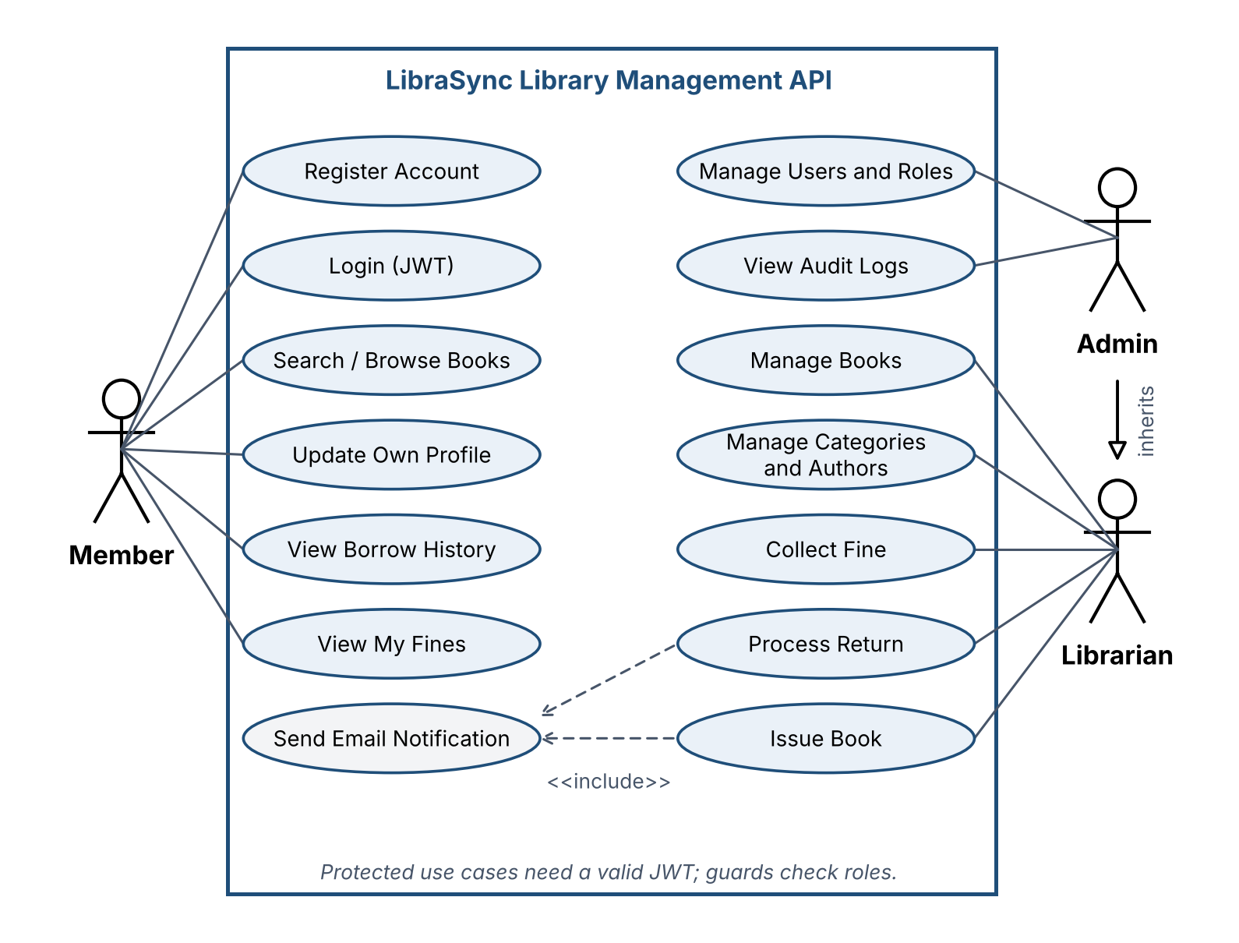
Figure 3.1: Use case diagram of LibraSync

3.3 Use case descriptions

UC-09 Issue book
Field | Description
Actor | Librarian (primary), Email service (secondary)
Preconditions | Librarian is logged in. The member account is active. The book exists.
Main flow | 1. Librarian submits the member id and book id.  2. The system validates the body against IssueBookDto.  3. The system starts a transaction and locks the book row.  4. It checks that copies are available and that the member has fewer than three active loans.  5. It reduces available_copies by one and inserts a borrow record due in 14 days.  6. It commits, writes an audit entry and sends the confirmation email.  7. It returns 201 with the new record.
Alternative flows | A1. No copy available: roll back and return 409 Conflict.  A2. Member or book not found: return 404 Not Found.  A3. Loan limit reached: roll back and return 409 Conflict.  A4. Database error: roll back and return 500 with a generic message.
Postcondition | Either the stock is reduced and a loan exists, or nothing has changed.

UC-10 Process return
Field | Description
Actor | Librarian (primary), Email service (secondary)
Preconditions | Librarian is logged in. The borrow record exists and its status is ISSUED or OVERDUE.
Main flow | 1. Librarian calls the return endpoint with the record id.  2. The system starts a transaction and loads the record with a lock.  3. It sets returned_at, sets status to RETURNED and increases available_copies by one.  4. If returned_at is after due_date, it inserts a fine of days late × BDT 5.  5. It commits, writes an audit entry and sends the receipt email.  6. It returns 200 with the updated record and the fine, if any.
Alternative flows | A1. Record not found: 404 Not Found.  A2. Record already returned: 409 Conflict.  A3. Any step fails: roll back all changes.
Postcondition | The book is back in stock and a fine exists for late returns.

3.4 ER diagram
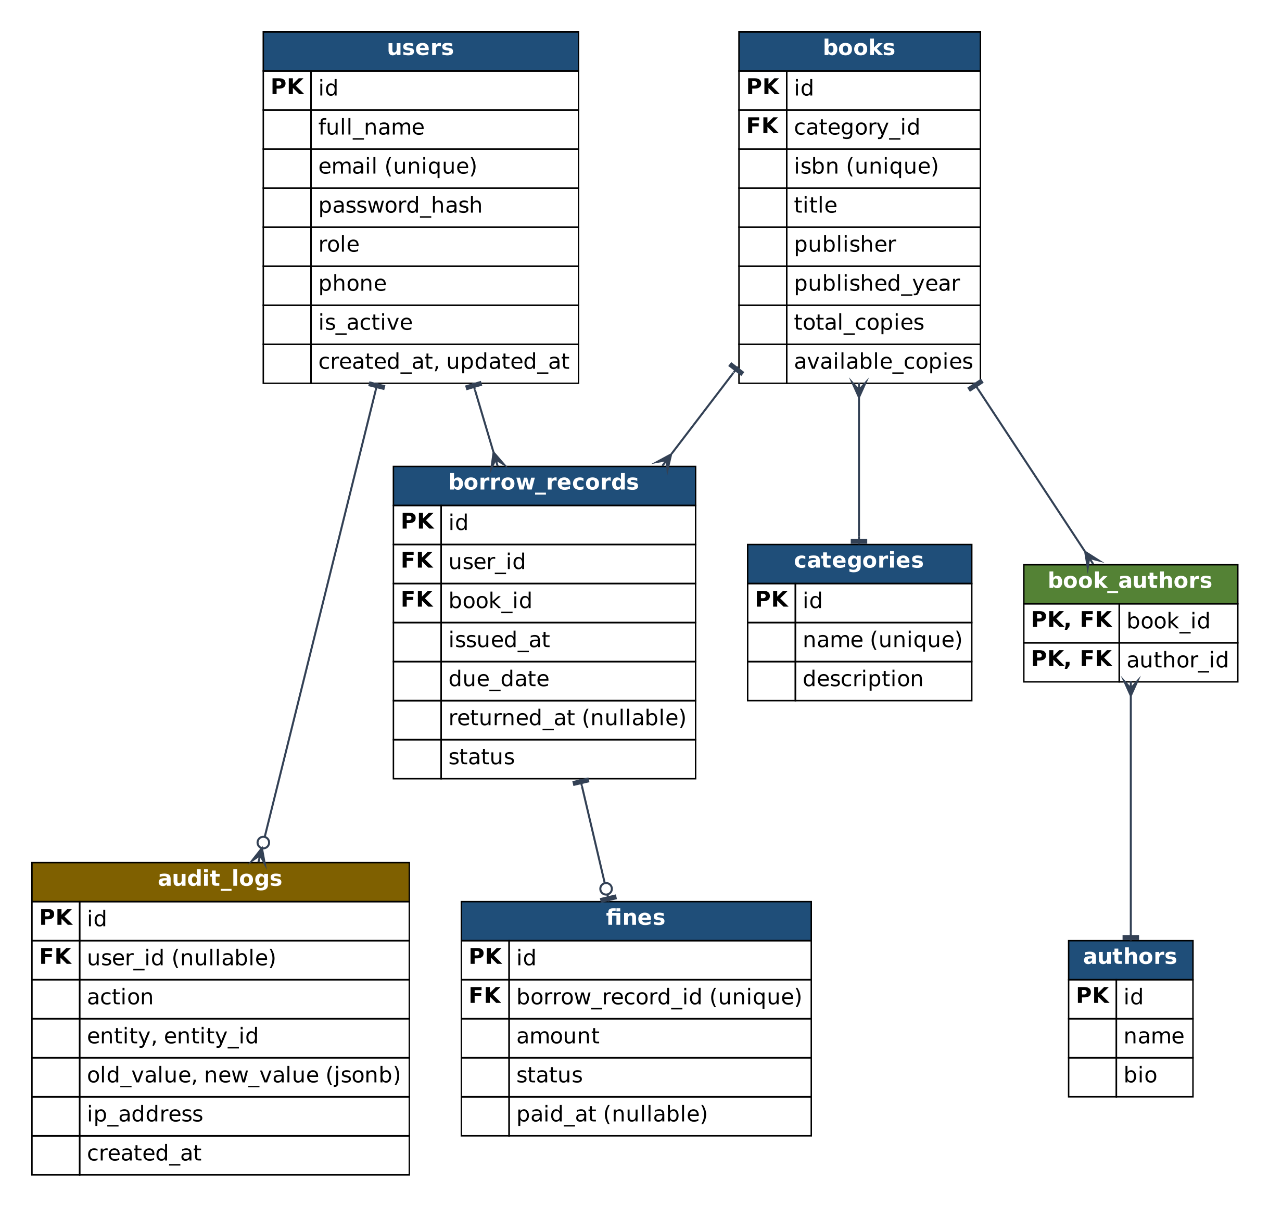
Figure 3.2: Entity relationship diagram (crow's foot notation)

3.5 Relationships
Relationship | Cardinality | Implemented by | On delete
Category has Books | 1 : N | books.category_id | RESTRICT
Book written by Authors | M : N | Junction table book_authors | CASCADE on junction rows
User borrows Books | 1 : N | borrow_records.user_id | RESTRICT
Book appears in Borrow records | 1 : N | borrow_records.book_id | RESTRICT
Borrow record may have a Fine | 1 : 0..1 | fines.borrow_record_id (unique) | RESTRICT
User performs audited actions | 1 : 0..N | audit_logs.user_id (nullable) | SET NULL

3.6 Keys and constraints
Table | Notable constraints
users | email unique and not null; role limited to ADMIN, LIBRARIAN, MEMBER; password_hash never exposed
categories | name unique
authors | name not null
books | isbn unique; check available_copies between 0 and total_copies; category_id foreign key
book_authors | Composite primary key (book_id, author_id)
borrow_records | status limited to ISSUED, RETURNED, OVERDUE; index on (user_id, status)
fines | borrow_record_id unique; amount greater than 0; status limited to UNPAID, PAID
audit_logs | old_value and new_value stored as jsonb; index on (entity, entity_id)

4. Database normalization
Normalization started from the sheet the library used before: one row per loan, with member and book details copied into every row. Two sample rows show the problems.

4.1 Unnormalized form (UNF)
Loan | Mem | Member | Email | ISBN | Title | Category | Authors | Issued | Due | Ret. | Fine
L-101 | M-12 | Tanvir Ahmed | tanvir@mail.com | 978-984-0001 | Web Systems Handbook | Computing | A. Karim; S. Rahman | 09-01 | 09-15 | 09-20 | 25
L-102 | M-12 | Tanvir Ahmed | tanvir@mail.com | 978-984-0002 | Data Modelling Basics | Computing | N. Chowdhury | 09-03 | 09-17

Dates are in 2026 (month-day); Ret. is the return date; Fine is in BDT.
Problems: the Authors cell of L-101 holds two values; the member's name and email repeat on every loan; the title and category repeat for every loan of the same book; and the fine is empty for loans that are on time or still open.

4.2 First normal form (1NF)
1NF requires atomic values and no repeating groups. The Authors cell is split so that each author gets a row. The row is now identified by (Loan, Author), a composite key.
Loan | Mem | Member | Email | ISBN | Title | Category | Author | Issued | Due | Ret. | Fine
L-101 | M-12 | Tanvir Ahmed | tanvir@mail.com | 978-984-0001 | Web Systems Handbook | Computing | A. Karim | 09-01 | 09-15 | 09-20 | 25
L-101 | M-12 | Tanvir Ahmed | tanvir@mail.com | 978-984-0001 | Web Systems Handbook | Computing | S. Rahman | 09-01 | 09-15 | 09-20 | 25
L-102 | M-12 | Tanvir Ahmed | tanvir@mail.com | 978-984-0002 | Data Modelling Basics | Computing | N. Chowdhury | 09-03 | 09-17

Primary key: (Loan, Author).

4.3 Second normal form (2NF)
2NF removes partial dependencies, where a non-key column depends on only part of a composite key. Every loan attribute (member, book, dates, fine) depends on Loan alone, not on Author. Those columns move to their own relation, and the author link is kept separately.
loan(Loan PK, Mem, MemberName, MemberEmail, ISBN, Title, Category,
Issued, Due, Returned, Fine)

loan_author(Loan FK, Author) PK (Loan, Author)

Every non-key column in loan now depends on the whole key. Redundancy remains: the member and book details still repeat on each loan.

4.4 Third normal form (3NF)
3NF removes transitive dependencies, where a non-key column depends on another non-key column. Three appear in loan:
- Loan → Mem → MemberName, MemberEmail. Member details belong in a users relation.
- Loan → ISBN → Title, Category. Book details belong in a books relation, with categories in their own relation.
- Authors depend on the book, not on the loan, so loan_author becomes book_authors linking books to a separate authors relation.
The fine is also split out. It is derived from the due date, the return date and the daily rate, it exists only for late returns, and it has its own status and payment date. Keeping it in borrow_records would leave most rows with empty fine columns.
Resulting relations:
users(id PK, full_name, email UNIQUE, password_hash, role, phone, is_active,
created_at, updated_at)
categories(id PK, name UNIQUE, description)
authors(id PK, name, bio)
books(id PK, category_id FK, isbn UNIQUE, title, publisher, published_year,
total_copies, available_copies)
book_authors(book_id FK, author_id FK) PK (book_id, author_id)
borrow_records(id PK, user_id FK, book_id FK, issued_at, due_date,
returned_at, status)
fines(id PK, borrow_record_id FK UNIQUE, amount, status, paid_at)
audit_logs(id PK, user_id FK NULL, action, entity, entity_id,
old_value, new_value, ip_address, created_at)

In each relation every determinant is a candidate key (id, email, isbn, name on categories, or the composite key of the junction table), so the design is also in Boyce-Codd normal form.

5. List of APIs
Base URL: http://localhost:3000/api/v1. All routes return JSON. The table lists 33 endpoints. Access levels: Public needs no token; Any user needs a valid token; Librarian+ means Librarian or Admin.

5.1 Response format
Successful responses use one envelope. List responses fill meta with pagination details.
{
"success": true,
"message": "Book issued",
"data": { "id": 41, "status": "ISSUED", "dueDate": "2026-11-09" },
"meta": null
}

Errors are produced by one global exception filter:
{
"success": false,
"statusCode": 409,
"error": "Conflict",
"message": "No copies available",
"path": "/api/v1/borrow-records",
"timestamp": "2026-10-26T08:05:11.000Z"
}

Status | Used when
200 / 201 | Request succeeded / resource created
400 | DTO validation failed or a parameter is malformed
401 | Token missing, invalid or expired; wrong login credentials
403 | Valid token but the role is not allowed, or the account is inactive
404 | Resource not found
409 | Duplicate unique value, no stock, loan limit reached, or the record is in the wrong state
500 | Unexpected error; the message is generic and details go to the server log

5.2 Endpoints

Auth
Method | Endpoint | Description | Access
POST | /auth/register | Register a member account | Public
POST | /auth/login | Log in and receive a JWT | Public
GET | /auth/me | Profile of the logged-in user | Any user

Users
Method | Endpoint | Description | Access
GET | /users | List users with pagination; filter by role | Admin
GET | /users/:id | Get one user | Admin
POST | /users | Create a staff account | Admin
PATCH | /users/:id | Update a profile; role and status only by Admin | Owner or Admin
DELETE | /users/:id | Deactivate a user (soft delete) | Admin

Categories
Method | Endpoint | Description | Access
GET | /categories | List categories | Any user
GET | /categories/:id | Get one category | Any user
POST | /categories | Create a category | Librarian+
PATCH | /categories/:id | Update a category | Librarian+
DELETE | /categories/:id | Delete a category; 409 if books use it | Librarian+

Authors
Method | Endpoint | Description | Access
GET | /authors | List authors | Any user
GET | /authors/:id | Get one author with their books | Any user
POST | /authors | Create an author | Librarian+
PATCH | /authors/:id | Update an author | Librarian+
DELETE | /authors/:id | Delete an author | Librarian+

Books
Method | Endpoint | Description | Access
GET | /books | Search and list: search, categoryId, page, limit | Any user
GET | /books/:id | Get one book with category and authors | Any user
POST | /books | Create a book | Librarian+
PATCH | /books/:id | Update a book | Librarian+
DELETE | /books/:id | Delete a book; 409 if it has active loans | Librarian+

Borrow records
Method | Endpoint | Description | Access
POST | /borrow-records | Issue a book (transaction) | Librarian+
PATCH | /borrow-records/:id/return | Record a return and create a fine if late (transaction) | Librarian+
GET | /borrow-records | List all loans; filter by status, user, date | Librarian+
GET | /borrow-records/my | The logged-in member's loan history | Member
GET | /borrow-records/:id | Get one loan | Librarian+ or owner

Fines
Method | Endpoint | Description | Access
GET | /fines | List fines; filter by status | Librarian+
GET | /fines/my | The logged-in member's fines | Member
PATCH | /fines/:id/pay | Mark a fine as paid | Librarian+

Audit logs
Method | Endpoint | Description | Access
GET | /audit-logs | List entries; filter by user, entity, date | Admin
GET | /audit-logs/:id | Get one entry | Admin

5.3 Requirement coverage
Where each course requirement is implemented in LibraSync.
Requirement | Implementation
Minimum
Multiple entities with CRUD | Full CRUD on users, categories, authors and books. Borrow records and fines have create, read and state-change endpoints. Audit logs are read-only.
Database integration | TypeORM with PostgreSQL; entities with @ManyToOne, @OneToMany and @ManyToMany
Data transaction | issueBook and returnBook use a QueryRunner with commit and rollback
JWT authentication and authorization | AuthModule, JwtStrategy, global JwtAuthGuard, RolesGuard
Input validation with DTOs | class-validator DTOs and a global ValidationPipe with whitelist and forbidNonWhitelisted
HTTP exception handling | Built-in HTTP exceptions and a global filter that maps PostgreSQL error 23505 to 409
Bonus
Middleware | RequestIdMiddleware and LoggerMiddleware
Custom decorators | @Roles(), @CurrentUser(), @Public()
Mailer | @nestjs-modules/mailer with Handlebars templates, sent to Mailtrap
Swagger UI | Served at /api/docs with bearer authentication
Interceptors | TransformInterceptor (envelope), TimingInterceptor, AuditInterceptor
Audit log | audit_logs table written by AuditInterceptor on every POST, PATCH and DELETE
Env | @nestjs/config with Joi validation; .env.example committed
Migrations | TypeORM migrations with synchronize off; schema built from scratch by migration:run
Response manipulation | Envelope with pagination meta; ClassSerializerInterceptor with @Exclude() on passwordHash
Database transaction (advanced) | Pessimistic write lock on the book row; fine creation inside the return transaction

6. Screenshots of functionality
Each screenshot below shows one function. The grey boxes are placeholders for the sample: in your report, replace each with a real screenshot that includes the request URL, the method, the request body where relevant, and the response status and body. Include failure cases as well as successes.
Replace with your screenshot
Show: the list of endpoint groups with the Authorize button
Figure 6.1: Swagger UI overview at /api/docs

Replace with your screenshot
Show: POST /auth/register with the response and no password hash
Figure 6.2: Registration (201 Created)

Replace with your screenshot
Show: POST /auth/login and the access token in the response
Figure 6.3: Login returns a JWT

Replace with your screenshot
Show: GET /books without the Authorization header
Figure 6.4: Missing token (401 Unauthorized)

Replace with your screenshot
Show: a Member calling POST /books
Figure 6.5: Wrong role (403 Forbidden)

Replace with your screenshot
Show: POST /books with category and author ids, and the response
Figure 6.6: Create book (201 Created)

Replace with your screenshot
Show: POST /books with an empty title and negative copies, and the list of messages
Figure 6.7: DTO validation error (400 Bad Request)

Replace with your screenshot
Show: POST /books with an ISBN that already exists
Figure 6.8: Duplicate ISBN (409 Conflict)

Replace with your screenshot
Show: GET /books?search=web&page=1&limit=10 with the meta block
Figure 6.9: Search with pagination

Replace with your screenshot
Show: the 201 response, then the books and borrow_records rows in the database client
Figure 6.10: Issue book: transaction success

Replace with your screenshot
Show: a forced error mid-transaction, and the unchanged available_copies
Figure 6.11: Issue book: rollback on failure

Replace with your screenshot
Show: PATCH /borrow-records/:id/return and the new fines row
Figure 6.12: Return book with late fine

Replace with your screenshot
Show: GET /audit-logs as Admin, filtered by entity
Figure 6.13: Audit log listing

Replace with your screenshot
Show: the loan confirmation message
Figure 6.14: Email in the Mailtrap inbox

Replace with your screenshot
Show: the terminal output of the migration command
Figure 6.15: Migrations run on an empty database

7. Implementation highlights

7.1 DTO validation
The create-book DTO states its rules on the class. The global ValidationPipe rejects anything that does not match and strips unknown properties.
export class CreateBookDto {
@ApiProperty({ example: '978-984-0001' })
@IsString() @Length(10, 17)
isbn: string;

@ApiProperty()
@IsString() @IsNotEmpty() @MaxLength(200)
title: string;

@ApiProperty({ example: 3 })
@IsInt() @Min(1) @Max(200)
totalCopies: number;

@ApiProperty()
@IsInt()
categoryId: number;

@ApiProperty({ type: [Number] })
@IsArray() @ArrayNotEmpty() @IsInt({ each: true })
authorIds: number[];
}

7.2 Issuing a book in a transaction
The service locks the book row, checks stock, updates it and inserts the loan. Any exception rolls everything back.
async issueBook(dto: IssueBookDto) {
const qr = this.dataSource.createQueryRunner();
await qr.connect();
await qr.startTransaction();
try {
const book = await qr.manager.findOne(Book, {
where: { id: dto.bookId },
lock: { mode: 'pessimistic_write' },
});
if (!book) throw new NotFoundException('Book not found');
if (book.availableCopies < 1)
throw new ConflictException('No copies available');

book.availableCopies -= 1;
await qr.manager.save(book);

const record = qr.manager.create(BorrowRecord, {
user: { id: dto.userId },
book: { id: book.id },
dueDate: addDays(new Date(), 14),
status: BorrowStatus.ISSUED,
});
await qr.manager.save(record);

await qr.commitTransaction();
return record;
} catch (err) {
await qr.rollbackTransaction();
throw err;
} finally {
await qr.release();
}
}

8. Conclusion and references
LibraSync meets the five minimum requirements and implements all ten bonus items. Stock changes are atomic, access is controlled by role, and every change leaves an audit record. The normalized schema has eight tables and avoids repeated member and book data.
Known limits: no reservation queue, no scheduled reminder emails, no refresh tokens, and no automated test suite beyond manual Postman runs. These are the next items to build: reservations, a scheduled job for due-date reminders, refresh-token rotation, and Jest tests for the transaction paths.

References
- NestJS documentation. https://docs.nestjs.com
- TypeORM documentation. https://typeorm.io
- PostgreSQL documentation. https://www.postgresql.org/docs/
- M. Jones, J. Bradley, N. Sakimura. JSON Web Token (JWT). RFC 7519. https://datatracker.ietf.org/doc/html/rfc7519
- R. Fielding, M. Nottingham, J. Reschke. HTTP Semantics. RFC 9110. https://datatracker.ietf.org/doc/html/rfc9110
- class-validator. https://github.com/typestack/class-validator

